Part I: MULTIPLE CHOICE QUESTIONS (5pts)1. The octet rule states that:  
a. Elements become stable by having 8 electrons  
b. Elements become stable by having 8 valence electrons  
c. Same number of protons and electrons  
d. Conserving electrons

2C

3 i

4D

5B

1. 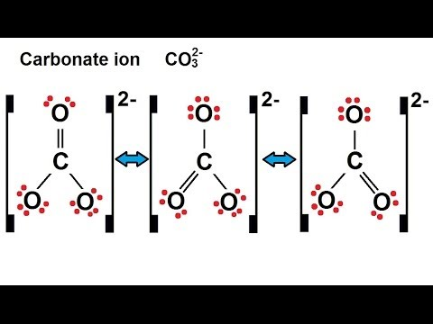A picture containing text, clock

   Description automatically generated

Part II: CONSTRUCTED QUESTIONS (95pts)

3.

a)CO2 : O(3.4) - C(2.6)=0.8<1.7 =>COVALENT

b)CaO : O(3.4) - Ca(1.3)=2.1>1.7=>IONIC

c)NaBr : Br(3.0) - Na(0.9)=2.1>1.7=>IONIC

d)MgI : I(2.7) - Mg(1.3)=1.4<1.7=>COVALENT

e)SO2 : O(3.4) - S(2.6)=0.8<1.7=>COVALENT

f)NI3 : N(3.0) - I(2.7)=0.3<1.7=>COVALENT

4.

1. HCCH(linear):non-polar.Bond angle:180

b) PF3(Trigonal Pyrimidal):polar.Bond angle:97

c)IF5(Square Pyramidal):polar.Bond angle:90

d) Cl2CO(Triangle Planar):polar.Bond angle:111.4

e)SiH2CL2():polar

f)SCN-(linear):polar.Bond angle:180

g) AlCl3(Trigonal Pyramidal):non-polar.Bond angle:109.5

h)H2O(v-shape):polar.Bond angle:104.5

5.

- Intramolecular forces are bonding forces which exist within molecules and determine the chemical properties of its compound.

- Intermolecular forces are attractive forces or non-bonding forces which exist between molecules and determine the physical properties of its compound.

- There are 4 types of intermolecular forces: Dipole-dipole forces, Ion-dipole forces, Hydrogen bond and London Dispersion forces.

+ Dipole-dipole forces are attractive forces between polar molecules.

Example: HBr, HCl, H20. Because the Bromine, chloride and Oxygen are partially negative and are attracted by the positive hydrogen

+ Ion-dipole forces are attractive forces between a polar molecule and an ion

Example: The solution of table salt (NaCl) in water Sodium chloride undergoes dissociation to form **Na+** and **Cl–** ions and water is polar solvent and also are MgCl2 and CaCl2.

+ Hydrogen bond is a special dipole-dipole interaction between N-H, O-H or F-H bonds

Example: H20, HF, NH3. Because all the Fluorine, Oxygen and Nitrogen are highly electronegative atoms so they can be linked to hydrogen atoms to form bonds

+ London Dispersion forces are an attractive force between the instantaneous dipole of the neon atom induces an instantaneous dipole in adjacent atoms.

Example: Helium, Methane (CH4) and Hexane (C6H6)

From the weakness to strongest: London Dispersion forces < Dipole-dipole Forces < Hydrogen bonding < Ion-ion forces

6.

Ans: The intermolecular forces can affect the melting and boiling points of the compound because the stronger the intermolecular forces are, the more increase in the bonding between molecules. If the intermolecular force strength increase, both of the melting and boiling points of the compound will rise